SUMMER J.A.M. RELEASE FORM

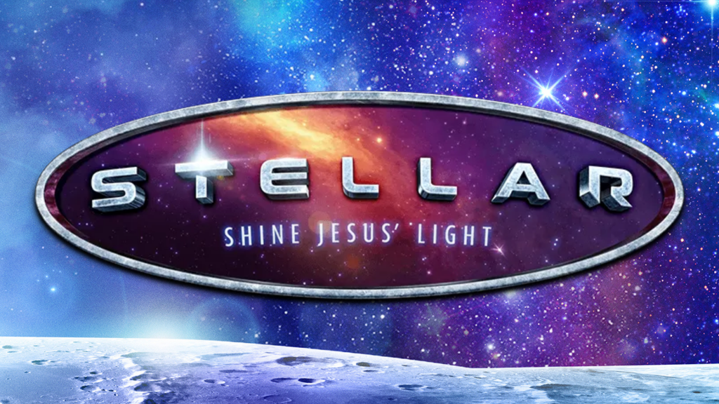
MEDICAL
Does your child have any special needs we should be aware of?
Physical Asthma
Behavioural Emotional
Learning Disabilities Social
Allergies: Medication / Other
My child has the following special needs/allergies
______________________________________________________________________

______________________________________________________________________

My child uses the following medication in support of the above mentioned special needs/allergies
______________________________________________________________________

______________________________________________________________________

ATTENTION - This medical and legal release must be completed and signed in order for your child to participate in SUMMER J.A.M. 2023

I_______________________________ (parent/guardian) give my permission to

_____________________________(child) to participate in Morinville Alliance Church’s Summer J.A.M

In the unlikely event of an emergency I authorize Morinville Alliance Church to act on my behalf and to have my child treated by an accredited physician in an approved emergency clinic or hospital. I further release Morinville Alliance Church and its officers and/or leadership in the event of an accident enroute, during and returning from the daily activities of Summer J.A.M 2023
Name of parent/guardian (please print)______________________________

Signature of parent/guardian______________________________________

Photo/Video release
I hereby give my permission for images of my child captured during Morinville Alliance Church’s Summer J.A.M. 2023 through video/photo/digital camera to be used solely for the purposes of Morinville Alliance Church promotional material and publications and waive any rights of compensation or ownership thereto.

Signature of parent/guardian_________________________________ Date____________

